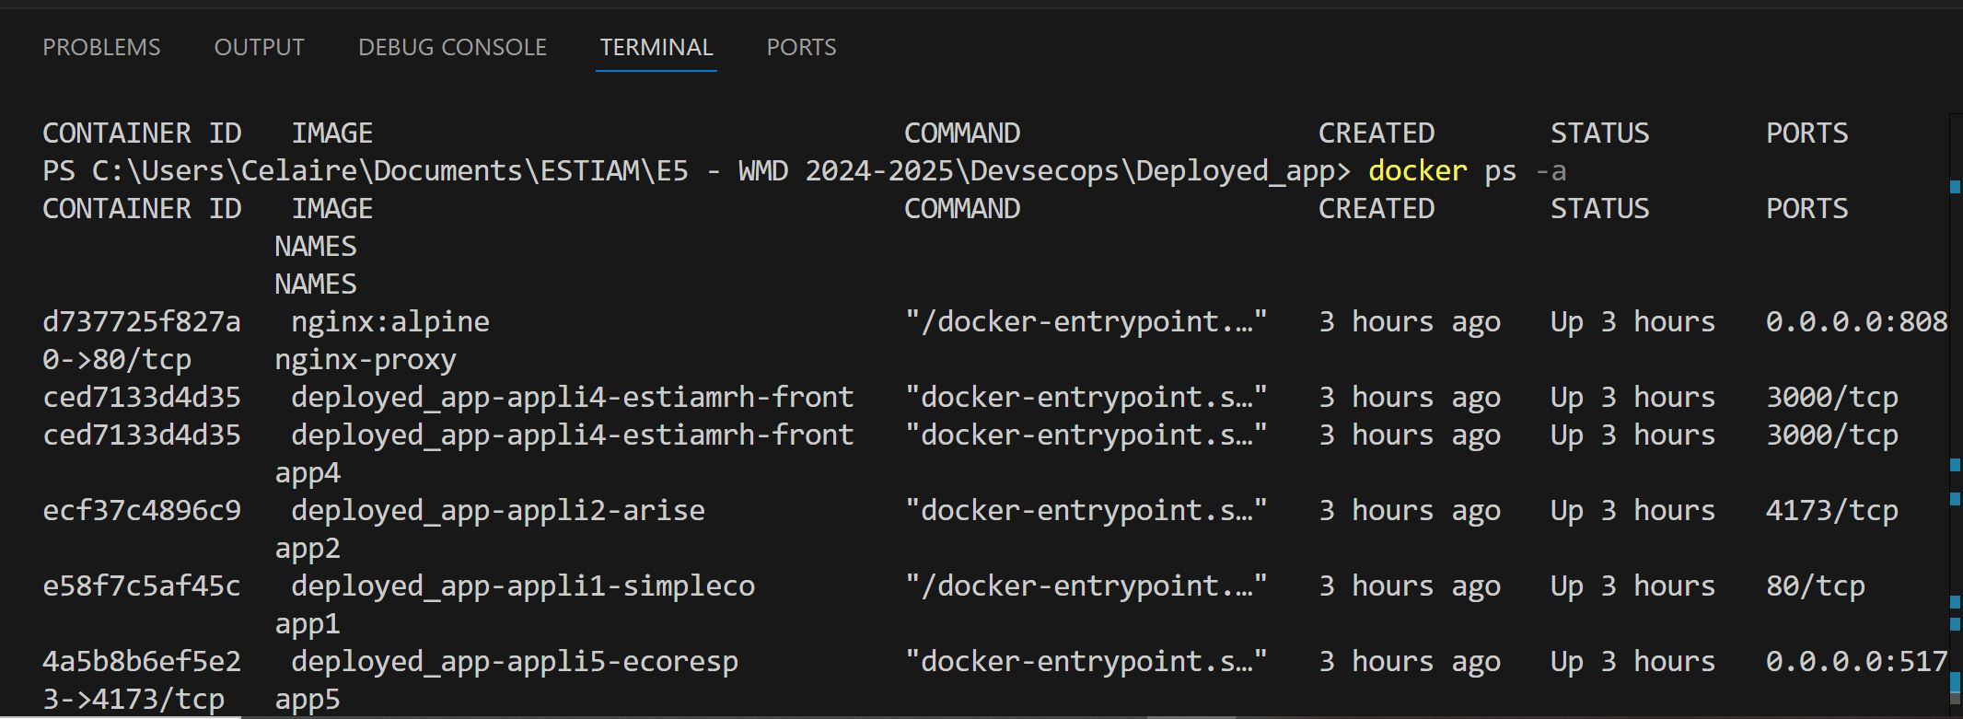

DEPLOIEMENT SUR DOCKERHUB

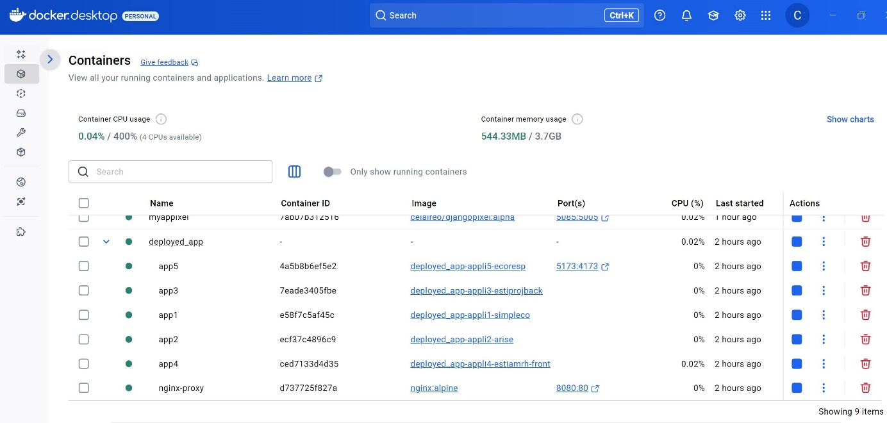

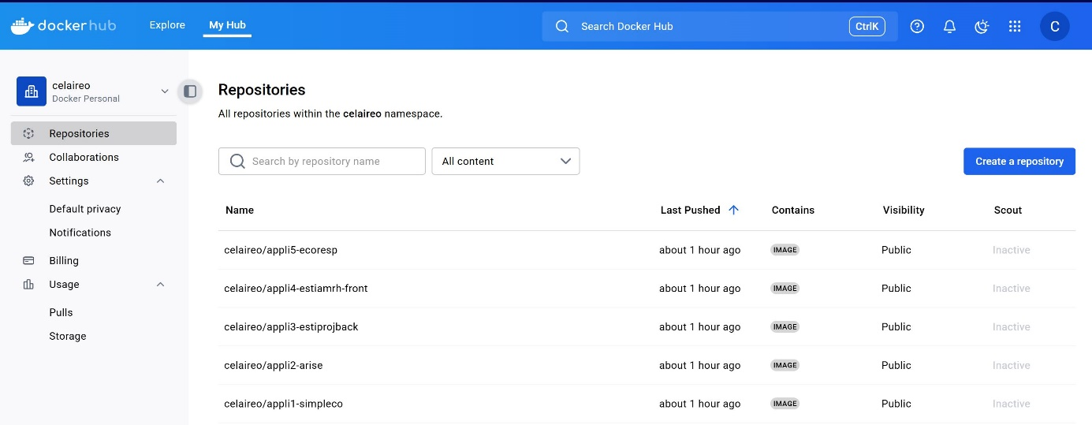

# App1 – appli1-arise

docker tag deployed_app-appli1-simpleco celaireo/appli1-simpleco:latest1

docker push celaire/appli1-simpleco:latest1

# App2 – appli2-arise

docker tag deployed_app-appli2-arise celaireo/appli2-arise:latest2

docker push celaire/appli2-arise:latest2

# App3 – appli3-estiprojback

docker tag deployed_app-appli3-estiprojback celaireo/appli3-estiprojback:latest3

docker push celaire/appli3-estiprojback:latest3

# App4 – appli4-estiamrh-front

docker tag deployed_app-appli4-estiamrh-front celaireo/appli4-estiamrh-front:latest4

docker push celaire/appli4-estiamrh-front:latest4

# App5 – appli5-ecoresp

docker tag deployed_app-appli5-ecoresp celaireo/appli5-ecoresp:latest5

docker push celaire/appli5-ecoresp:latest5

